There are a lot of factors to consider when you are settling in a particular state or city. Besides the cost of living there are things such as what kind of life you want to live. For example, despite having to pay for transportation in all states, the transportation cost can be interchangeable such as car maintenance or public transportation such as trains or buses. The difference is the lifestyle changes such as being depended on a car and having to drive around to be able to reach your destinations unlike living in a more metropolitan city such as Washington DC and New York (where a lot of areas are accessible by either bus and train) where you are not are as reliant on cars and in fact,more expensive to maintain because factors such as parking space and tolls per density.

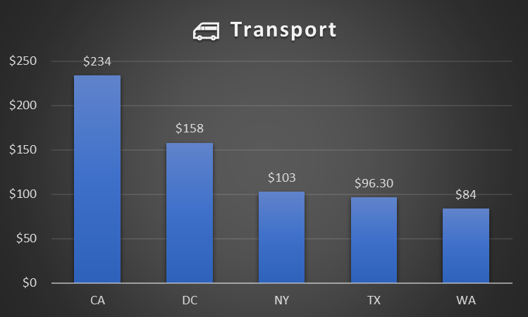

Something to consider is how much you value your time when you are commuting to your job. Outside of cities where you have to drive, you are required to put in more energy into the drive itself. With that in mind there are other factors such as whether you can navigate driving in more hectic environments. With cities having a higher risk of car accidents, you should consider whether you think it is worth the risk and if you are “skilled” enough to want to drive in a city.

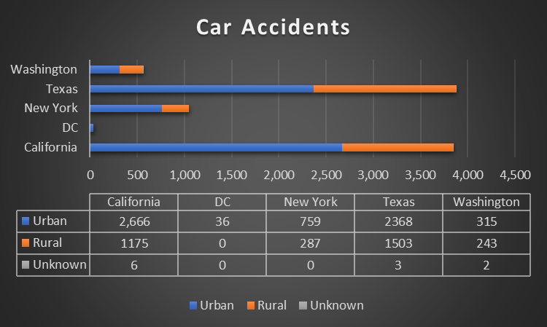

So another factor to consider is whether you are willing to become more reliant on public transportation rather than driving yourself and having certain advantages such as having the convenience to travel whenever you want.

Another factor to consider is your personal preference with your lifestyle. If you live in a metropolitan city, there are different things to consider such as whether you are willing to live in an apartment or a house. What activities you like to indulge in such as eating or drinking in a variety of different locations per density, shopping in more ubiquitous stores, and exploring a city’s landscape and culture. Whereas living outside the city the activities you are more likely to indulge in the landscape itself such as mountains, lakes, and the road, interpersonal restaurants such as local diners and cafes with repeating customers.

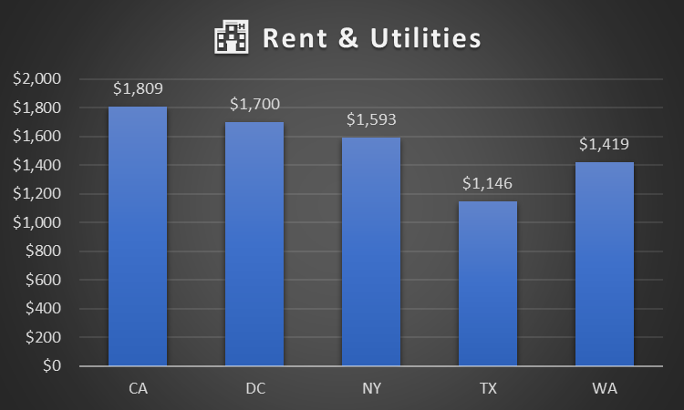

The benefits to living in a more “rural” area besides being more isolated, is having to pay less in rent and utilities which can be enticing if your goal is to save as much money as possible.